# CHAPTER 2: INSTALLATION

## Theory

WebSphere Application Server Network

Deployment (ND) has three configuration concepts, which are cells, nodes, and servers. There configuration items are managed by deployment managers, administrative agents, and job managers.

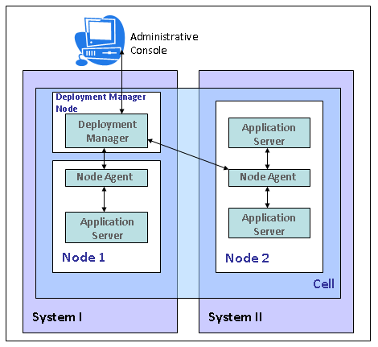

Application server is the core of the WebSphere Application Server where you can run your applications. Each application server has its own JVM where you can deploy one or more applications. Application server provides the platform that your application requires such as database and messaging connectivity.

Node is a grouping of application servers in order to configure and manage them. It is possible to have multiple nodes in Network Deployment installation, but nodes cannot cross the limits of the operating system instance of which they are installed on. Administrative console enables you to manage multiple nodes installed on different operating system instances.

Cell contains multiple nodes that are administered by deployment manager. Deployment manager uses node agents within the cell to manage application servers installed on distributed and multiple nodes. Node agent is the administrative server running on each node to manage application servers. Each node has its own copy of configuration and they are synchronized with the master repository which resides on deployment manager.

IBM Installation Manager is tool for installation and maintenance of Installation Manager based packages such as WebSphere Application Server. You can install and run Installation Manager in graphical, silent, console and command-line mode.

With Installation Manager you can install, update, modify, roll back and uninstall the packages.

*Installation* is the primary task for Installation Manager. From version 8 of Websphere Application Server, you can use this tool for installation and maintenance.

*Update* feature allows you to locate and install the updates for the products that are installed using Installation Manager. You can both install fixpacks and interim fixes available for your application server.

*Modify* allows you to change features used during installation. You can add/remove features such as language packs for Websphere Application Server.

*Roll back* gives you the possibility to remove an update and go back to the previous version of you application server. This feature is really handy when you have problems with the newly installed update. Installation manager keeps earlier versions and uses those files to roll back.

*Uninstall* feature allows you to remove packages that are installed using Installation Manager.

Beside these features, IBM Installation Manager allows you to create response files that can be used in installation of the packages like Websphere Application Server. To do that, use “-skipInstall” option to just simulate installation and “-record target_response_file.xml” option and complete all installation steps. At the end, the output file can be used as response file for further installations in silent mode.

## AIM

The aim of the following lab exercise is to install Websphere Application Server both using graphical interface where available and command line interface.

Following steps are required:

Task 1: Graphical Installation Manager Installation

Task 2: Graphical WebSphere Application Server Installation

Task 3: Adding new Profile via GUI

Task 4: Silent installation of Installation Manager

Task 5: Silent installation of WebSphere Application Server

Task 6: Adding new Profile via command line

We need following packages to perform the lab exercise:

* IBM Installation Manager  
  http://www-01.ibm.com/support/docview.wss?uid=swg24033586
* IBM WebSphere Application Server 8.5 Network Deployment Trial  
  https://www14.software.ibm.com/webapp/download/preconfig.jsp?id=2012-06-14+12%3A34%3A36.201813R&S_TACT=&S_CMP=

# Lab Exercise 2: INSTALLATION

|  |
| --- |
|  |

## Graphical Installation Manager Installation

## Graphical WebSphere Application Server Installation

## Adding new Profile via GUI

## Silent installation of Installation Manager

## Silent installation of WebSphere Application Server

## Adding new Profile via command line

GUI Ins. Man.

GUI WAS Ins.

GUI  
Profile

Silent Ins. Man

Silent WAS Ins.

Silent  
Profile



**Task 1: Graphical Installation Manager Installation  
Step 1:** Unzip the installation file of IBM Installation Manager and within that directory run “**install**” command.



**Step 2:** Select the check marks as below and then click on “**Next**”.

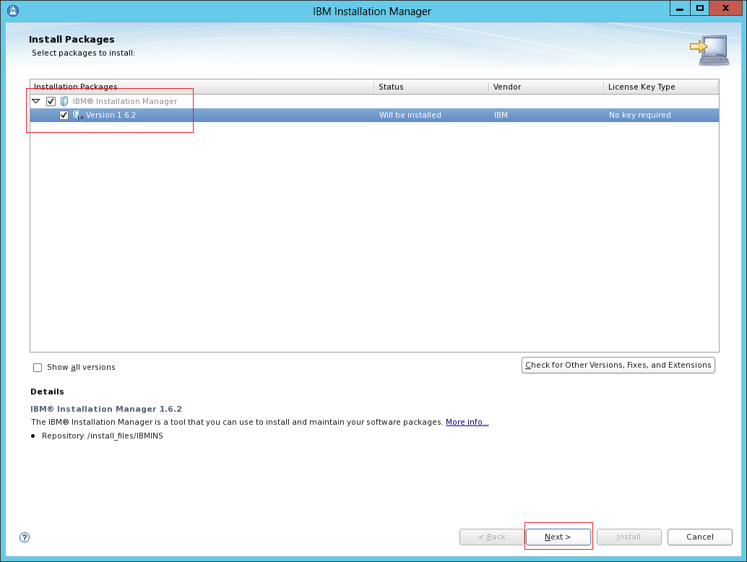

**Step 3:** Accept the license agreement and then click **“Next”**. You can print the agreement for later use by “**Print All”.**

GUI Ins. Man.

GUI WAS Ins.

GUI  
Profile

Silent Ins. Man

Silent WAS Ins.

Silent  
Profile



**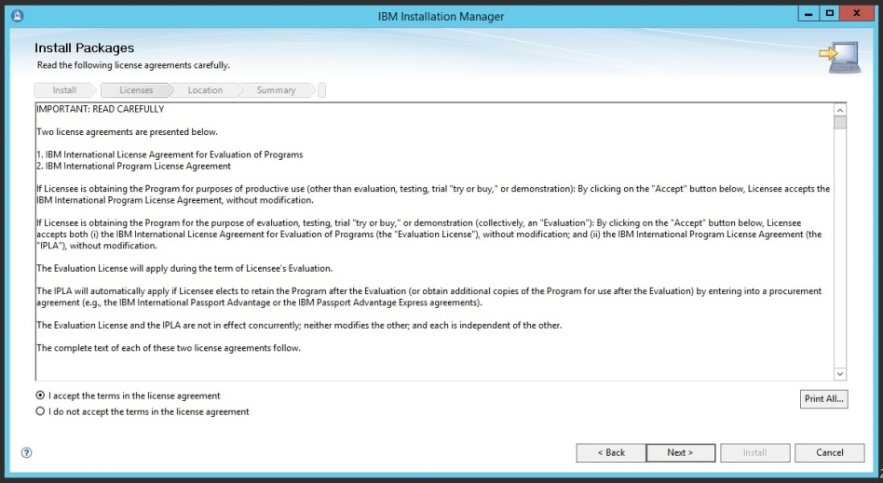  
Step 4:** Choose the installation directory (/opt/IBM/InstallationManager/eclipse) and then click **“Next”**.

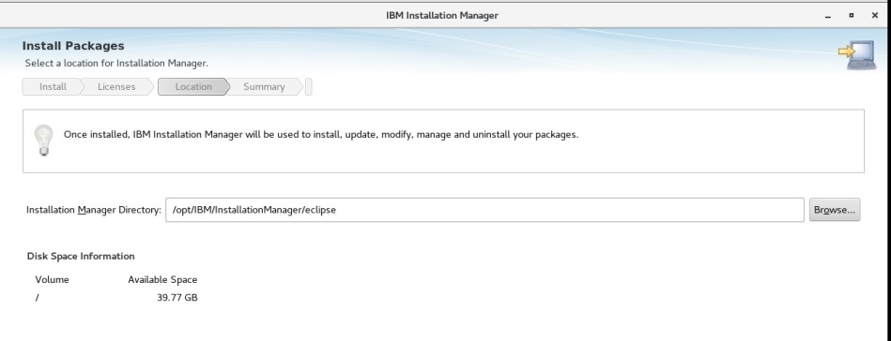

**Step 5:** View summary and click **“Install”** to start installation.

GUI Ins. Man.

GUI WAS Ins.

GUI  
Profile

Silent Ins. Man

Silent WAS Ins.

Silent  
Profile



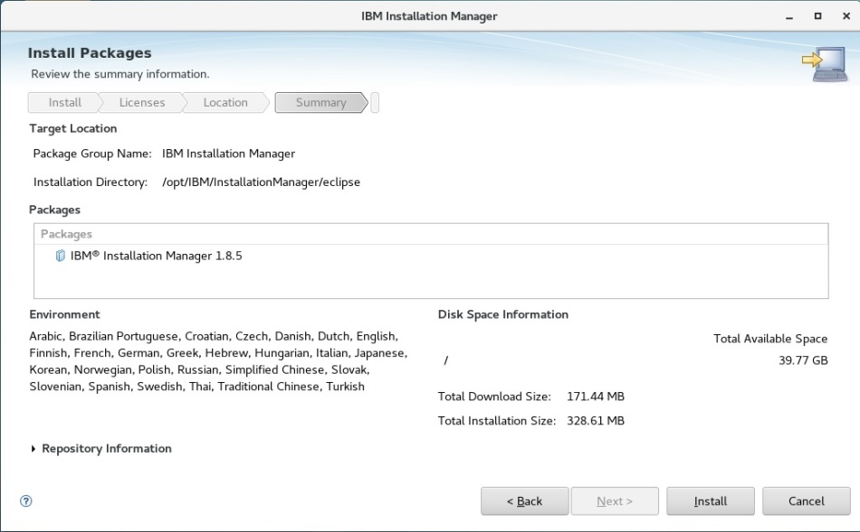

**Task 1 is complete!**

GUI Ins. Man.

GUI WAS Ins.

GUI  
Profile

Silent Ins. Man

Silent WAS Ins.

Silent  
Profile



**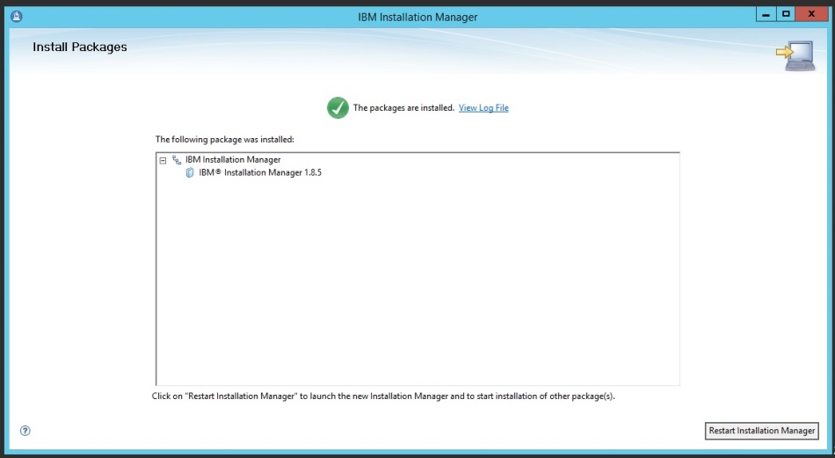  
Step 6:** Click **“Restart Installation Manager”** to run newly installed Installation Manager.

**Task 2: Graphical WebSphere Application Server Installation**

GUI Ins. Man.

GUI WAS Ins.

GUI  
Profile

Silent Ins. Man

Silent WAS Ins.

Silent  
Profile



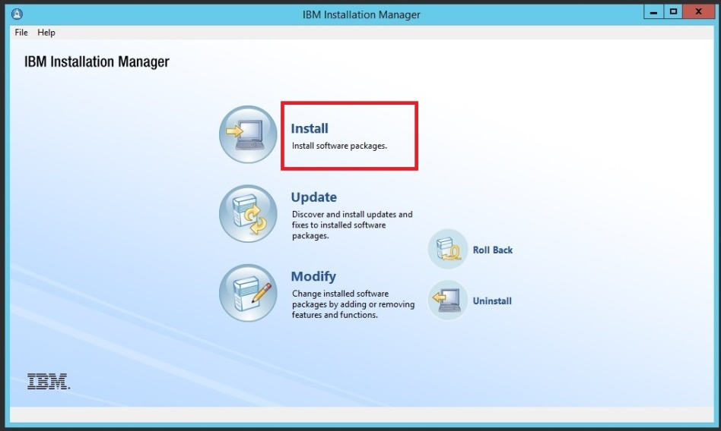

**Step 1:** In order to set repositories to install Websphere, click **“File>Preferences”**.

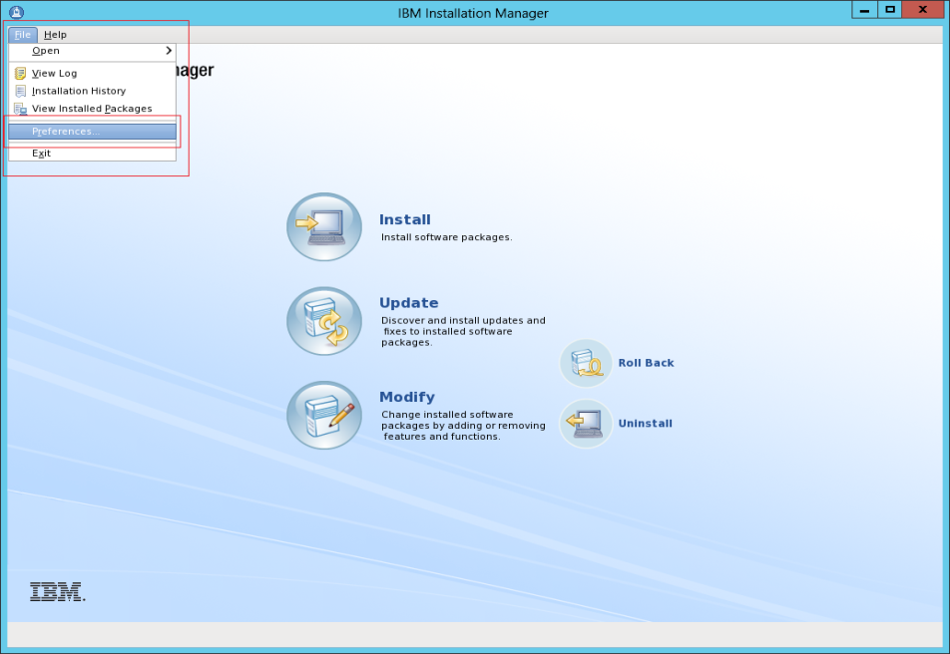

**Step 2:** Click “**Add Repository”** and change directory to the installation file of Websphere Application Server.

GUI Ins. Man.

GUI WAS Ins.

GUI  
Profile

Silent Ins. Man

Silent WAS Ins.

Silent  
Profile



<http://www.ibm.com/software/repositorymanager/com.ibm.websphere.ND.v90>

**Step 3:** Click **“OK”** when you select all the required repositories. For the installation purpose, we will have repositories configured, one for WebSphere and other for IBM SDK required for WebSphere installation.

**Step 4:** Select the packages you want to install and then click “**Next”**.

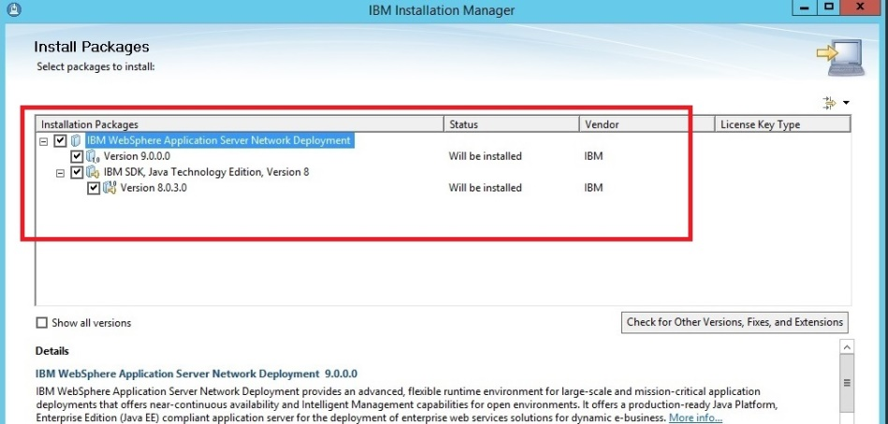

**Step 5:** Accept the license agreement and then click **“Next”**.

GUI Ins. Man.

GUI WAS Ins.

GUI  
Profile

Silent Ins. Man

Silent WAS Ins.

Silent  
Profile



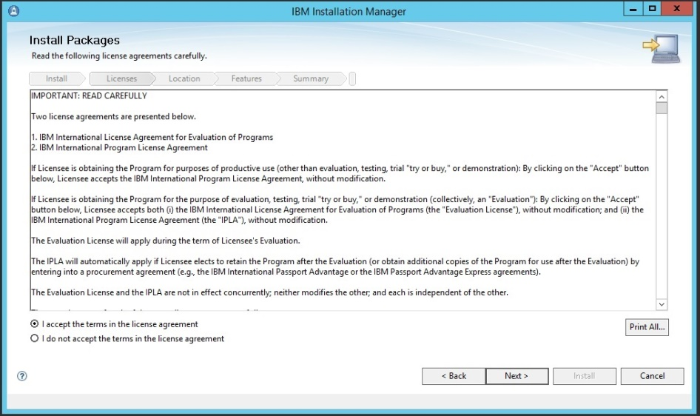

**Step 6:** Select the shared resources directory and then click **“Next”**. This directory will be shared between different packages that might be installed.

GUI Ins. Man.

GUI WAS Ins.

GUI  
Profile

Silent Ins. Man

Silent WAS Ins.

Silent  
Profile



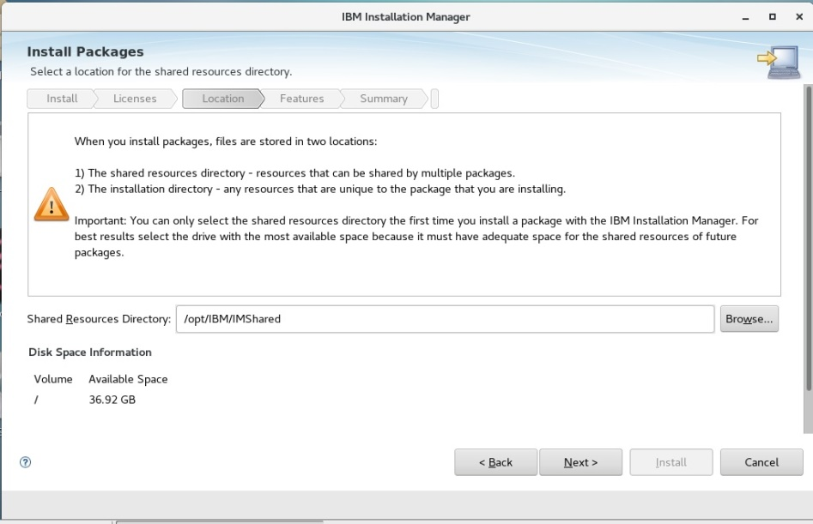

GUI Ins. Man.

GUI WAS Ins.

GUI  
Profile

Silent Ins. Man

Silent WAS Ins.

Silent  
Profile



**Step 6:** Select the installation directory. We accept the default value, “/opt/IBM/WebSphere/AppServer” and then click **“Next”**.

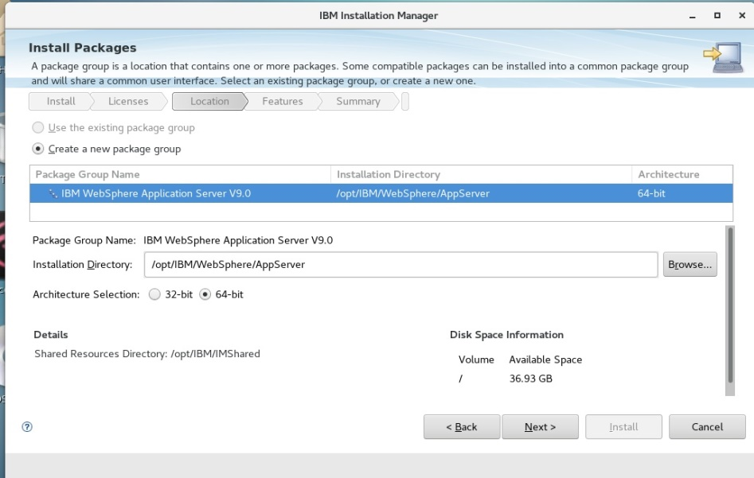

**Step 7:** Select different language translations and then click **“Next”**.

GUI Ins. Man.

GUI WAS Ins.

GUI  
Profile

Silent Ins. Man

Silent WAS Ins.

Silent  
Profile



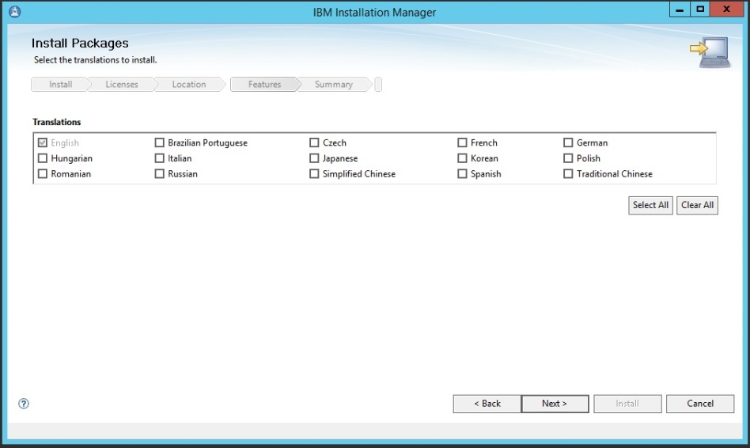

GUI Ins. Man.

GUI WAS Ins.

GUI  
Profile

Silent Ins. Man

Silent WAS Ins.

Silent  
Profile



**Step 8:** Select the features you need to install and then click **“Next”**.

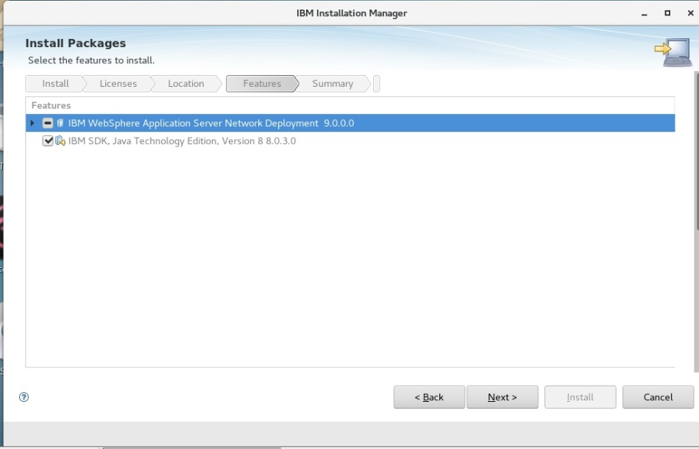

GUI Ins. Man.

GUI WAS Ins.

GUI  
Profile

Silent Ins. Man

Silent WAS Ins.

Silent  
Profile



**Step 9:** Review the summary information, and then click **“Install”** to start installation. If you need to change the options, simply go back and then update.

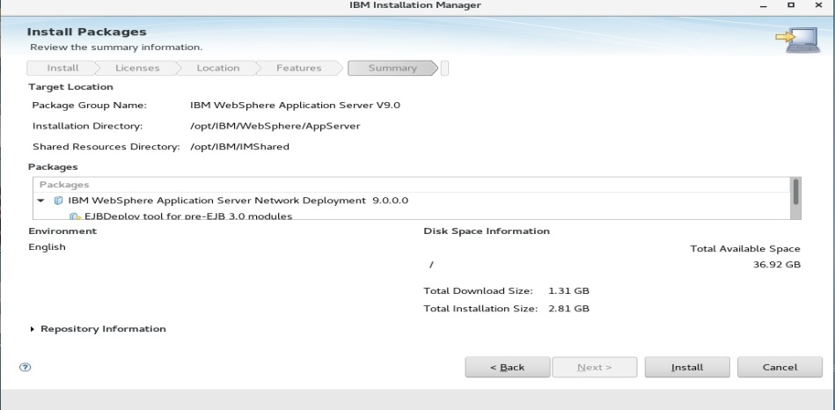

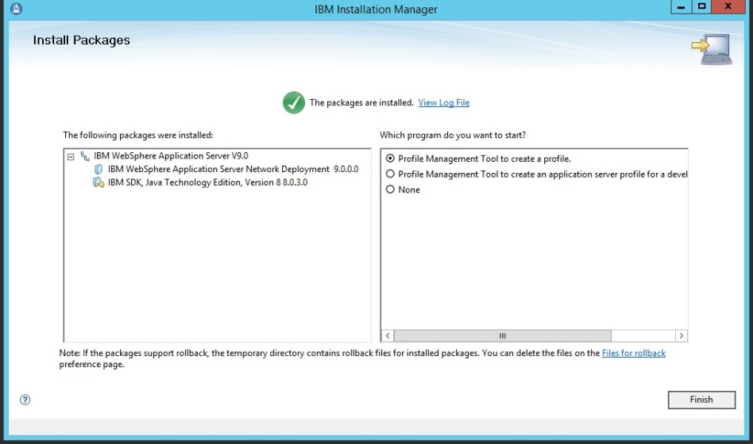

**Task 2 is complete!**

**Task 3: Adding new Profile via GUI**

**Step 1:** Select “Profile Management Tool to create a profile” and then click **“Finish”**.

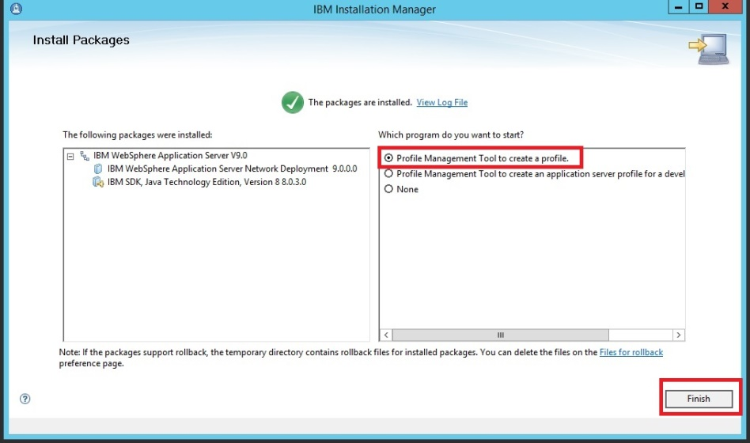

Profile Management Tool can also be opened like this:

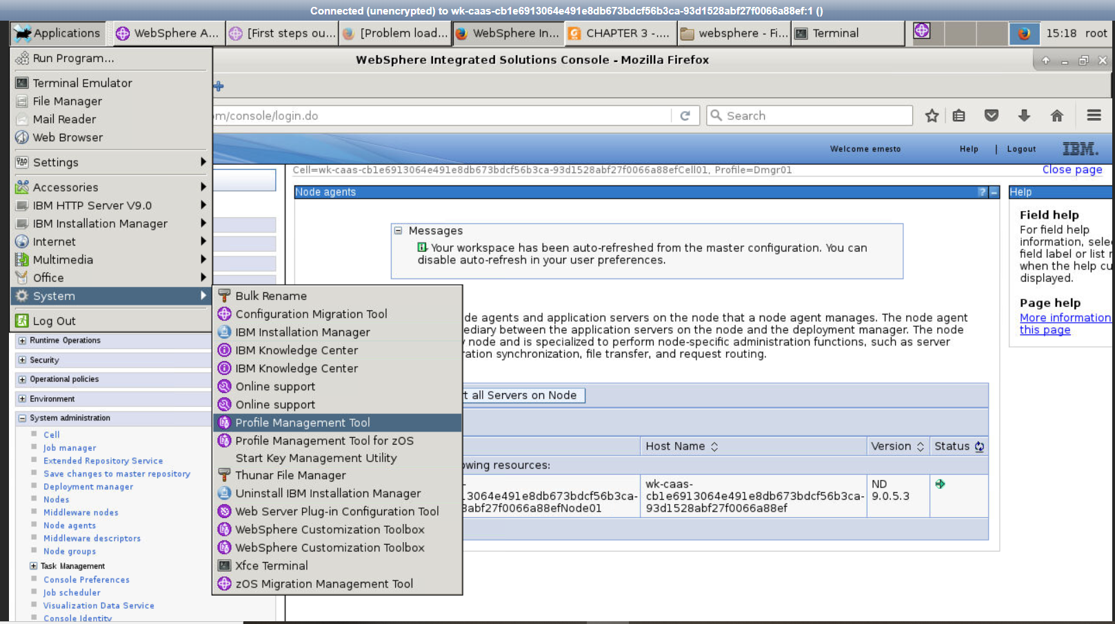

GUI Ins. Man.

GUI WAS Ins.

GUI  
Profile

Silent Ins. Man

Silent WAS Ins.

Silent  
Profile



**Step 1:** Click on **“Create”** to start adding a new profile.

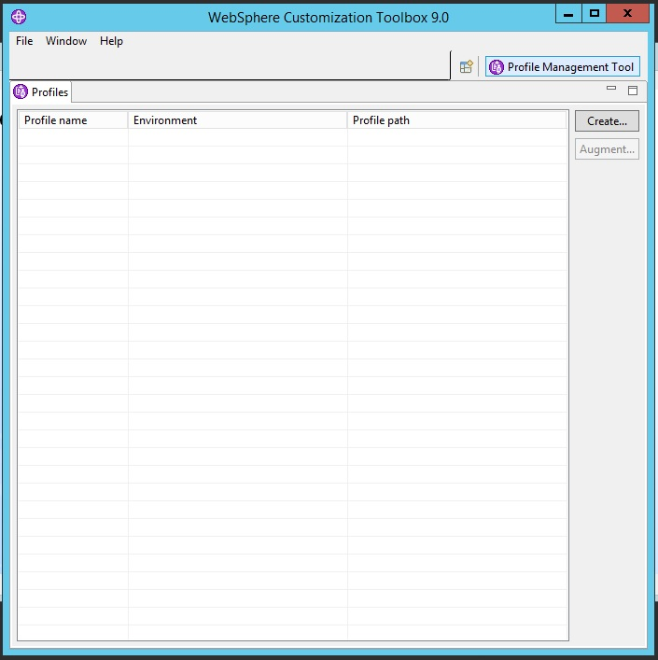

GUI Ins. Man.

GUI WAS Ins.

GUI  
Profile

Silent Ins. Man

Silent WAS Ins.

Silent  
Profile



**Step 2:** Choose **“Cell”** type profile and click **“Next”**. This will add a deployment manager and a federated application server.

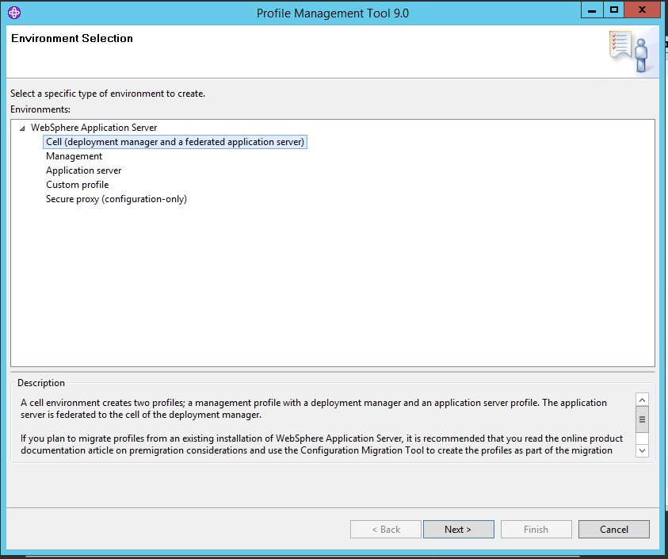

GUI Ins. Man.

GUI WAS Ins.

GUI  
Profile

Silent Ins. Man

Silent WAS Ins.

Silent  
Profile



**Step 3:** Select “Advanced profile creation” to configure details and click **“Next”**.

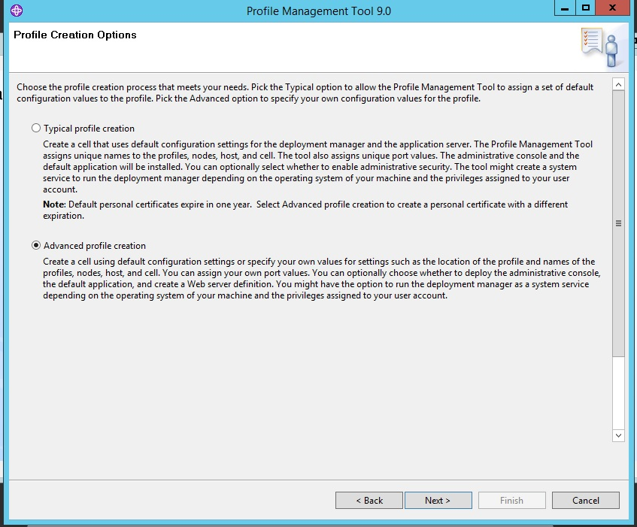

GUI Ins. Man.

GUI WAS Ins.

GUI  
Profile

Silent Ins. Man

Silent WAS Ins.

Silent  
Profile



**Step 4:** Accept the values as below and then click **“Next”**.

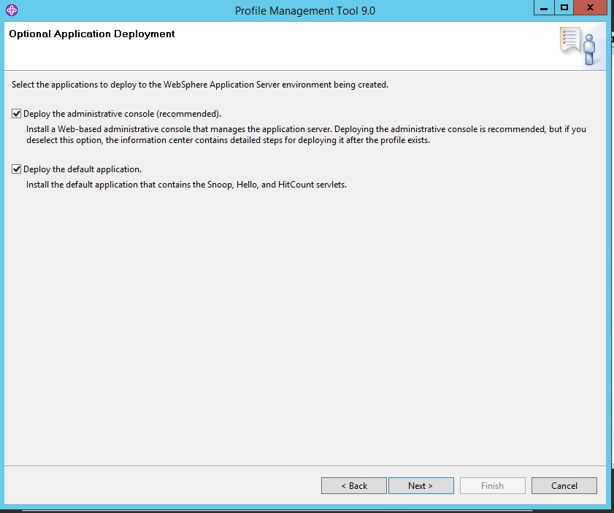

GUI Ins. Man.

GUI WAS Ins.

GUI  
Profile

Silent Ins. Man

Silent WAS Ins.

Silent  
Profile



**Step 5:** You can set the values for names of Deployment manager and application server profile. It is also possible to set profile directory.

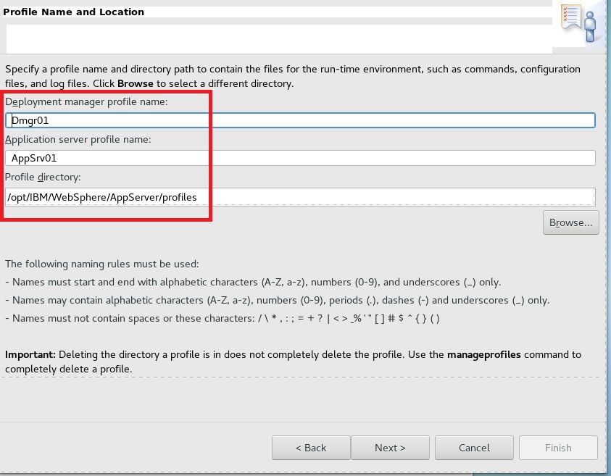

GUI Ins. Man.

GUI WAS Ins.

GUI  
Profile

Silent Ins. Man

Silent WAS Ins.

Silent  
Profile



**Step 6:** In this step, use default set names for node, host and cell, and then click **“Next”**.

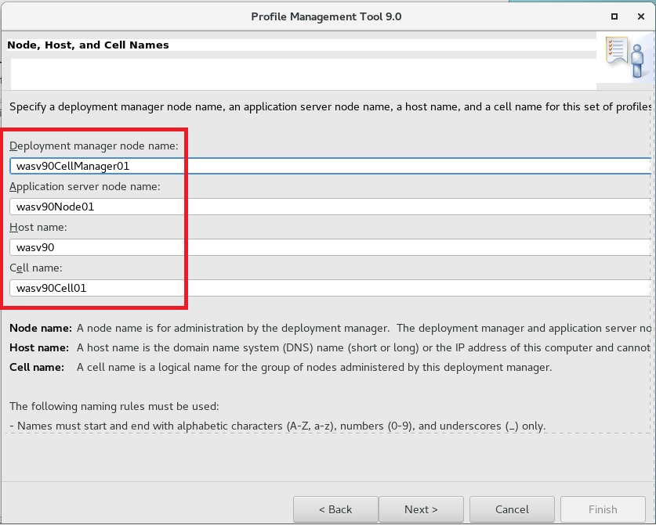

GUI Ins. Man.

GUI WAS Ins.

GUI  
Profile

Silent Ins. Man

Silent WAS Ins.

Silent  
Profile



**Step 7:** Uncheck the box “Enable administrative security” and then click **“Next”**. We will manage security settings in the next chapters.

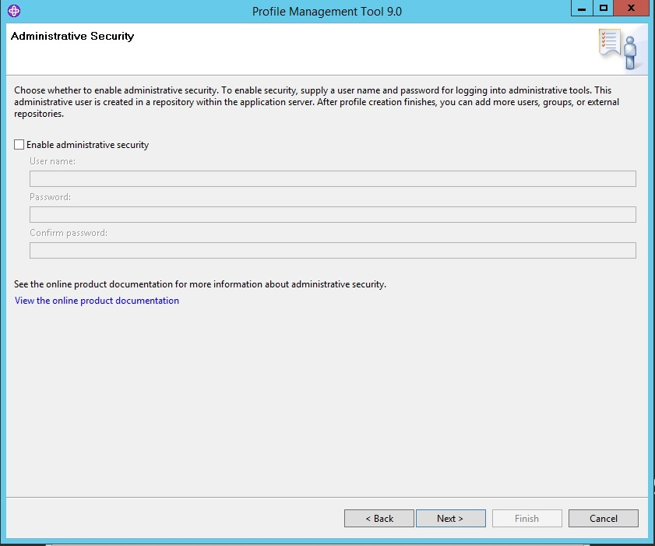

GUI Ins. Man.

GUI WAS Ins.

GUI  
Profile

Silent Ins. Man

Silent WAS Ins.

Silent  
Profile



**Step 7:** You can use your existing certificates in this step. We will create new certificates and to do that click **“Next”**.

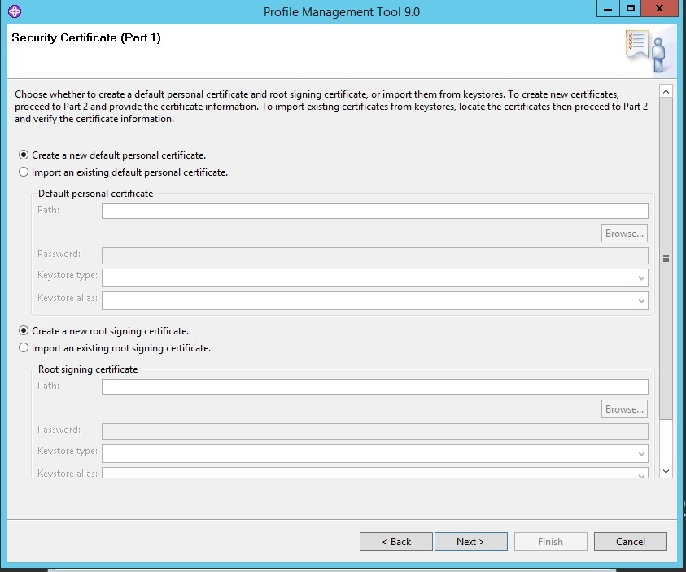

GUI Ins. Man.

GUI WAS Ins.

GUI  
Profile

Silent Ins. Man

Silent WAS Ins.

Silent  
Profile



**Step 8:** In this step we will create new certificate. You can provide the values of depending on your organization and then click **“Next”**.

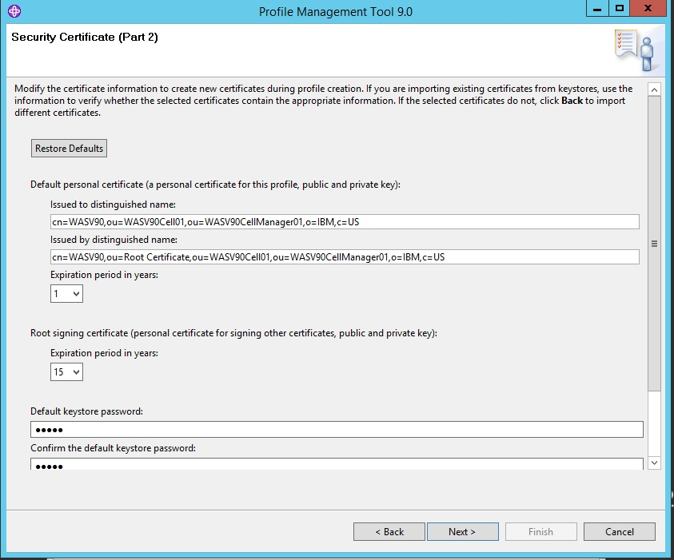

GUI Ins. Man.

GUI WAS Ins.

GUI  
Profile

Silent Ins. Man

Silent WAS Ins.

Silent  
Profile



**Step 9:** In the following 3 steps, you need to configure ports needed for the installation. We accept the default numbers and continue installation by clicking **“Next”**.

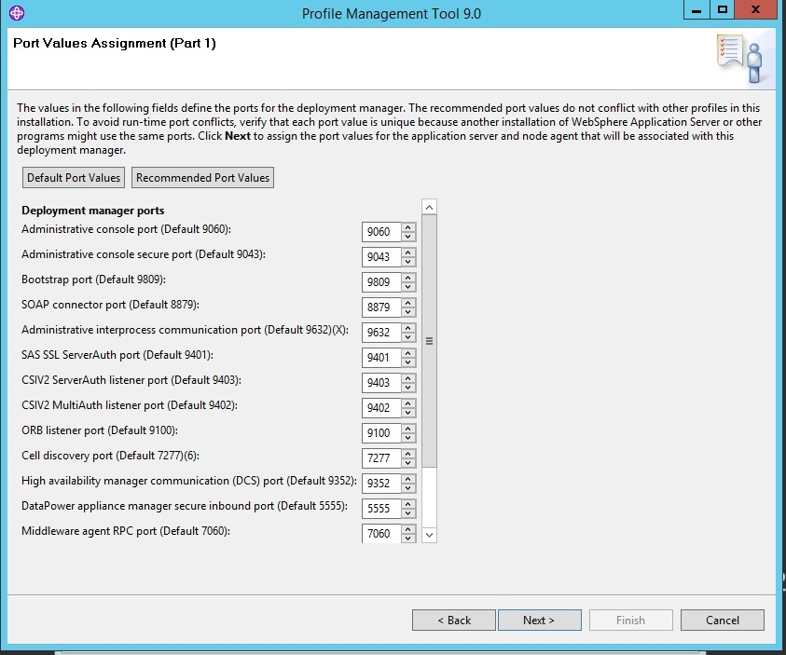

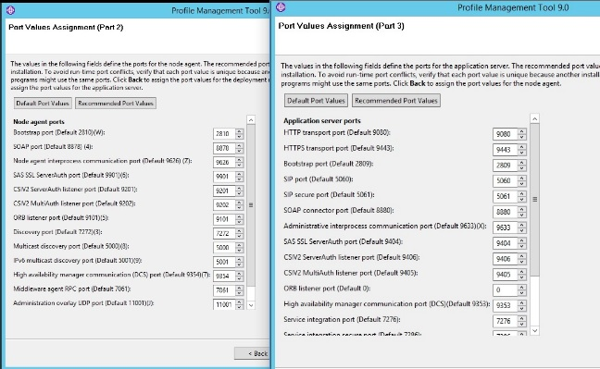

GUI Ins. Man.

GUI WAS Ins.

GUI  
Profile

Silent Ins. Man

Silent WAS Ins.

Silent  
Profile



**Step 10:** Leave unchecked the option “Run the deployment manager process as Linux service” option and then click **“Next”**.

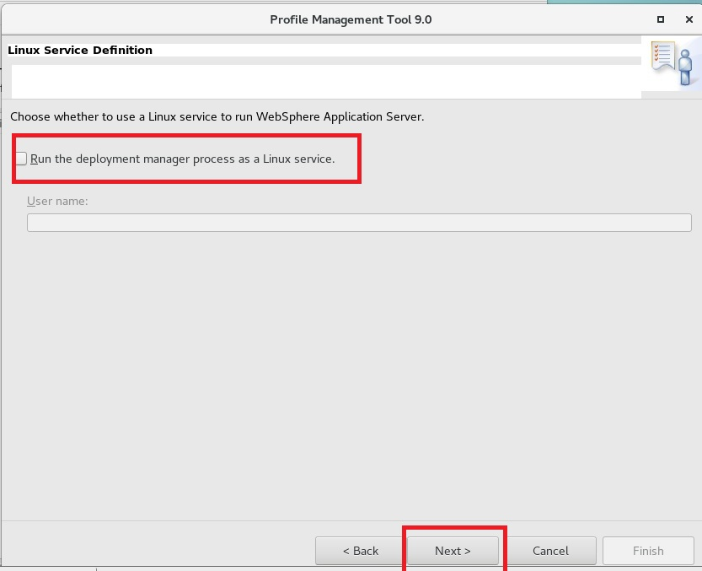

GUI Ins. Man.

GUI WAS Ins.

GUI  
Profile

Silent Ins. Man

Silent WAS Ins.

Silent  
Profile



**Step 11:** Uncheck “Create a Web server definition” and then click **“Next”**.

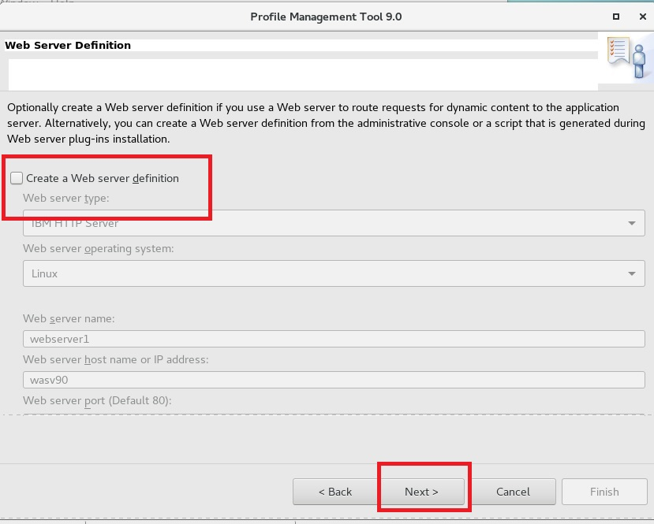

GUI Ins. Man.

GUI WAS Ins.

GUI  
Profile

Silent Ins. Man

Silent WAS Ins.

Silent  
Profile



**Step 12:** In this step, you can see the configuration summary and click **“Create”** to complete profile creation.

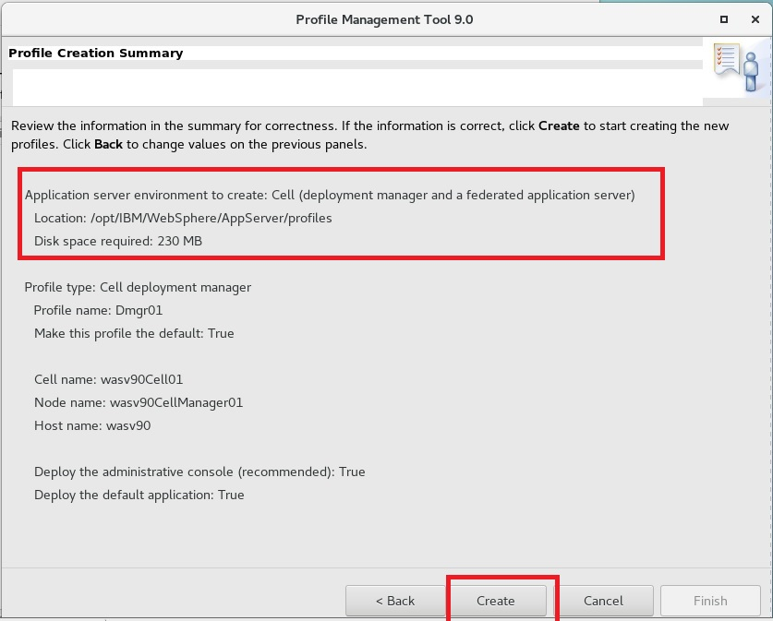

GUI Ins. Man.

GUI WAS Ins.

GUI  
Profile

Silent Ins. Man

Silent WAS Ins.

Silent  
Profile



**Step 13:** Profile creation is completed. Make sure that “Launch the First steps console” and then click **“Finish”**.

**Note:** Any warning/error can be ignored.

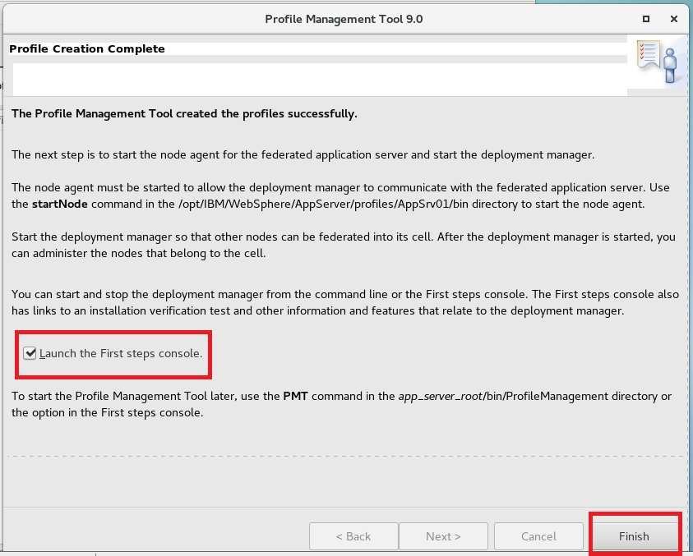

GUI Ins. Man.

GUI WAS Ins.

GUI  
Profile

Silent Ins. Man

Silent WAS Ins.

Silent  
Profile



**Step 14:** Click on **“Installation verification”**.

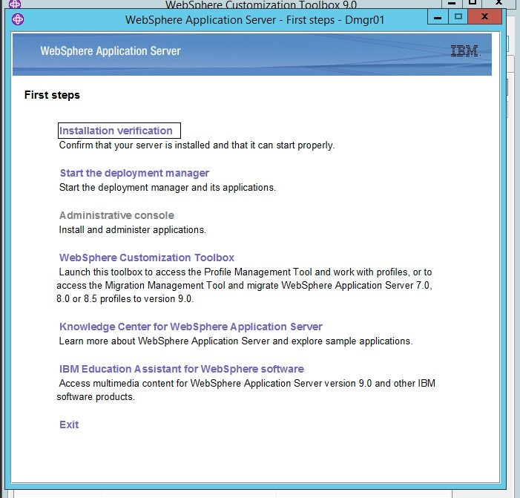

**Step 15:** Check for the message “Server dmgr open for e-business”.

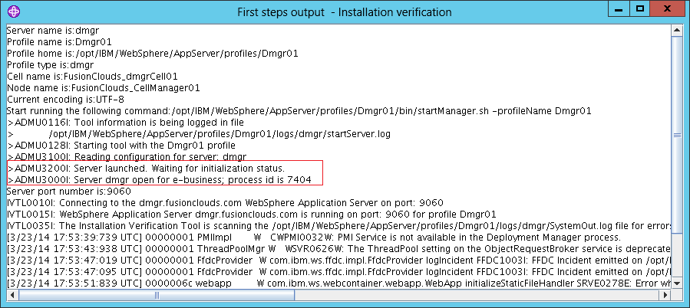

**Task 3 is complete!**

GUI Ins. Man.

GUI WAS Ins.

GUI  
Profile

Silent Ins. Man

Silent WAS Ins.

Silent  
Profile



**Task 4: Silent installation of Installation Manager**

**Step 1:** Change to the unzipped installation directory of Installation Manager.

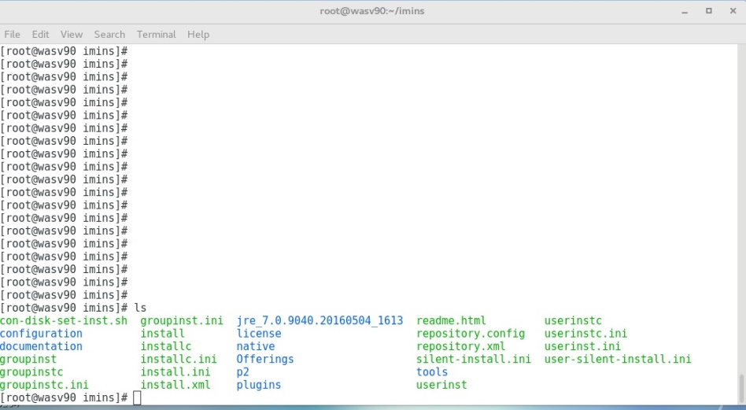

GUI Ins. Man.

GUI WAS Ins.

GUI  
Profile

Silent Ins. Man

Silent WAS Ins.

Silent  
Profile



**Step 2:** Issue the comment “installc –log /tmp/ibmim.log –acceptLicense” to install Installation Manager. In case of errors, check the log file for troubleshooting.

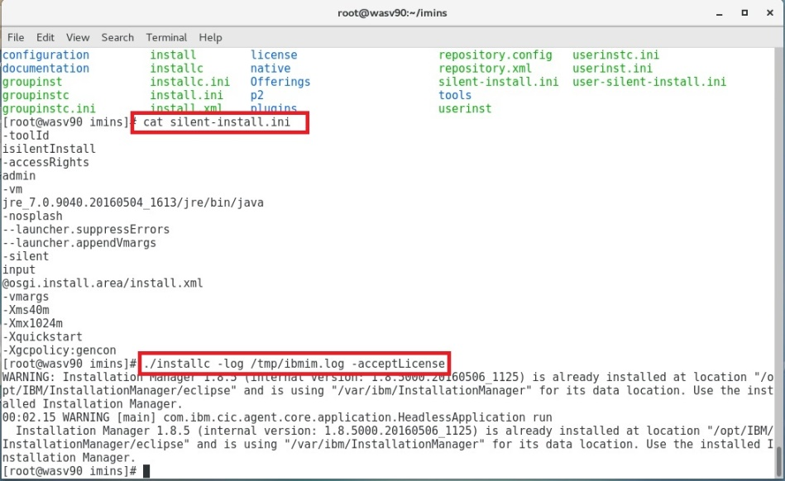

**Task 4 is complete!**

GUI Ins. Man.

GUI WAS Ins.

GUI  
Profile

Silent Ins. Man

Silent WAS Ins.

Silent  
Profile



**Task 5: Silent installation of WebSphere Application Server**

**Step 1:** Change directory to the newly installed IBM Installation Manager and then prepare a response file.



**Sample response file***<?xml version="1.0" encoding="UTF-8"?>*

*<!--The "acceptLicense" attribute has been deprecated. Use "-acceptLicense" command line option to accept license agreements.-->*

*<agent-input acceptLicense='true'>*

*<server>*

*<repository location='/root/nd'/>*

*<repository location='/root/dsk'/>*

*</server>*

*<profile id='IBM WebSphere Application Server V9.0' installLocation='/opt/IBM/WebSphere/AppServer'>*

*<data key='eclipseLocation' value='/opt/IBM/WebSphere/AppServer'/>*

*<data key='user.import.profile' value='false'/>*

*<data key='cic.selector.os' value='linux'/>*

*<data key='cic.selector.arch' value='x86'/>*

*<data key='cic.selector.ws' value='gtk'/>*

*<data key='cic.selector.nl' value='en'/>*

*</profile>*

*<install modify='false'>*

*<offering id='com.ibm.websphere.ND.v90' version='9.0.0.20160526_1854' profile='IBM WebSphere Application Server V9.0' features='core.feature,ejbdeploy,thinclient,embeddablecontainer,com.ibm.java.jdk.v8,samples' installFixes='none'/>*

*</install>*

*<preference name='com.ibm.cic.common.core.preferences.eclipseCache' value='/opt/IBM/IMShared'/>*

*<preference name='com.ibm.cic.common.core.preferences.connectTimeout' value='30'/>*

*<preference name='com.ibm.cic.common.core.preferences.readTimeout' value='45'/>*

*<preference name='com.ibm.cic.common.core.preferences.downloadAutoRetryCount' value='0'/>*

GUI Ins. Man.

GUI WAS Ins.

GUI  
Profile

Silent Ins. Man

Silent WAS Ins.

Silent  
Profile



*<preference name='offering.service.repositories.areUsed' value='true'/>*

*<preference name='com.ibm.cic.common.core.preferences.ssl.nonsecureMode' value='false'/>*

*<preference name='com.ibm.cic.common.core.preferences.http.disablePreemptiveAuthentication' value='false'/>*

*<preference name='http.ntlm.auth.kind' value='NTLM'/>*

*<preference name='http.ntlm.auth.enableIntegrated.win32' value='true'/>*

*<preference name='com.ibm.cic.common.core.preferences.preserveDownloadedArtifacts' value='true'/>*

*<preference name='com.ibm.cic.common.core.preferences.keepFetchedFiles' value='false'/>*

*<preference name='PassportAdvantageIsEnabled' value='false'/>*

*<preference name='com.ibm.cic.common.core.preferences.searchForUpdates' value='false'/>*

*<preference name='com.ibm.cic.agent.ui.displayInternalVersion' value='false'/>*

*<preference name='com.ibm.cic.common.sharedUI.showErrorLog' value='true'/>*

*<preference name='com.ibm.cic.common.sharedUI.showWarningLog' value='true'/>*

*<preference name='com.ibm.cic.common.sharedUI.showNoteLog' value='true'/>*

*</agent-input>*

GUI Ins. Man.

GUI WAS Ins.

GUI  
Profile

Silent Ins. Man

Silent WAS Ins.

Silent  
Profile



**Step 2:** Issue installation command using response file. “imcl –acceptLicense input response_file.xml –log /tmp/wasins.log”

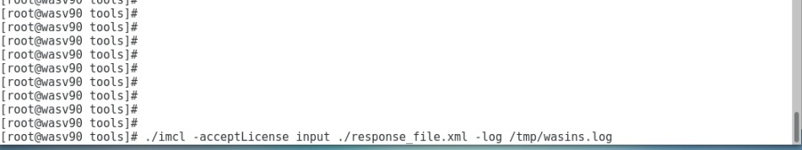

**Task 5 is complete!**

GUI Ins. Man.

GUI WAS Ins.

GUI  
Profile

Silent Ins. Man

Silent WAS Ins.

Silent  
Profile



**Task 6: Adding new Profile via command line**

**Step 1:** In order to add new profile, use following command:

“manageprofiles.sh -create –templatePath /opt/IBM/WebSphere/AppServer/profileTemplates/default”

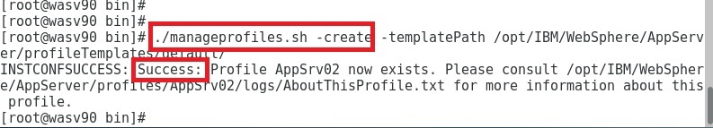

**Task 6 is complete!**

GUI Ins. Man.

GUI WAS Ins.

GUI  
Profile

Silent Ins. Man

Silent WAS Ins.

Silent  
Profile



You can verify the installations by browsing: “https://localhost:9043/ibm/console”

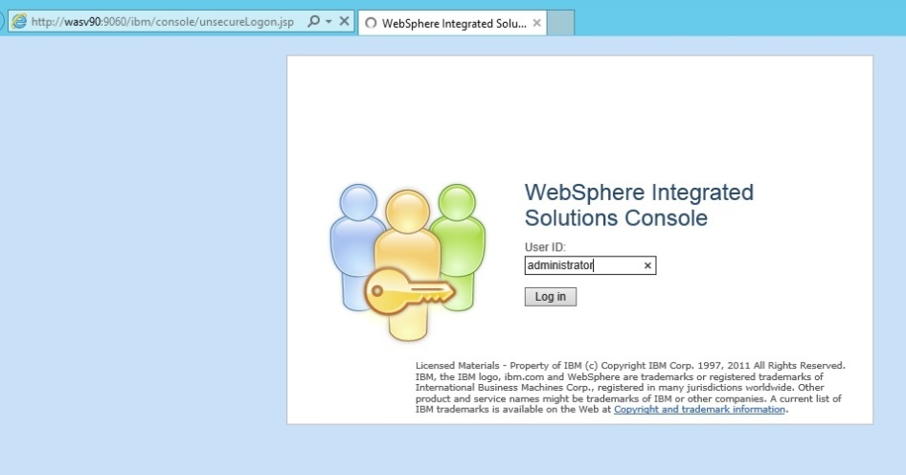

Use any name to authenticate.

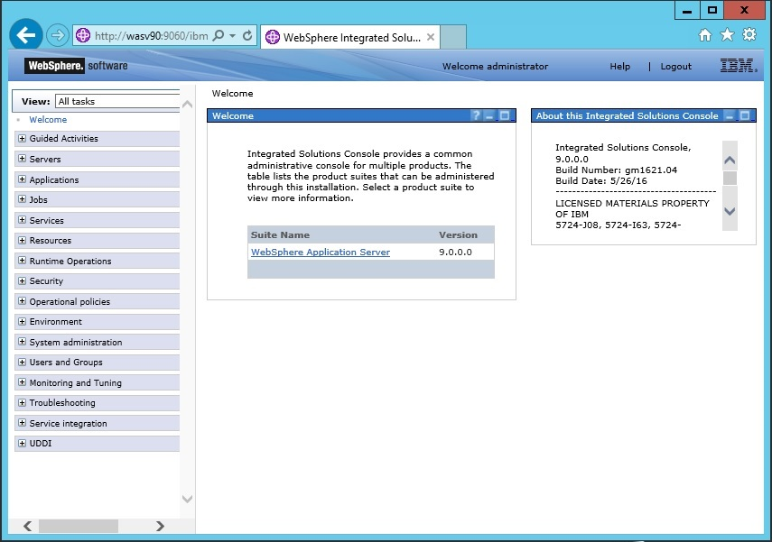

# SUMMARY

Websphere Application Server has three main concepts, application server, node and cell. Cells manage nodes that can be installed on multiple systems but, nodes cannot span on multiple operating system instances. Nodes manage multiple application servers, where each has its own JVM to host multiple applications, using node agents. IBM Installation Manager can install, update, modify, roll back and uninstall WebSphere Application Server and similar packages. You can use Installation Manager on graphical or silent modes. In order to install Websphere Application Server, we need to first install IBM Installation Manager and then configure repositories. In Network Deployment version, it is a best practice to first create deployment manager profile.

# INDEX

Application server 21

Cell 22

Deployment manager 22

IBM Installation Manager 22

Node 21

node agents 22